Automatic Explicit Identification of Red-Sea Troughs and its Application for the Climatology of the Levant

Hadas Saaroni, Tzvi Harpaz. Pinhas Alpert. Baruch Ziv

1. **Introduction**

The Red Sea Trough (RST) is a low-pressure system extending toward the Levant from the south. It is one of the northward extensions of the African Monsoon, and the most frequent of these, attributed to the Lee Effect of continuous mountain ridges along the Red Sea. It is present during 19% of the days annually: mostly in the fall, slightly less during the winter, and fades out by mid-spring. The RST transports hot and dry air from the Arabian Peninsula and surroundings toward the Levant via southeasterly winds, often accompanied by haze or dust storms. It is mostly a lower-level system, supplemented by upper-level westerlies or by an anticyclonic flow, hence mostly without rain over the East Mediterranean (EM).

During conditions of dry air, implied by the lower-level easterly flow (e.g., Saaroni et al. 1998), and an absence of upper-level dynamic ascent, the resulting RST is a dry system with no rain (Dayan et al. 2001, Ziv et al. 2005).

Southeasterly winds which blow the dry air over the sandy basins in Saudi Arabia, Iraq and Syria often give birth to dust storms and transport this dust westward toward the Levant (Dayan et al. 2008, Enzel et al. 2008, Ganor et al. 2010a, b, Erel et al. 2013).

The first attempts to identify the RST were made by Koplowitz (1973), Ben-Rubi (1980) and Ronberg (1984), as part of an automated classification of the regional synoptic systems. They based their method on observations of Middle Eastern meteorological stations. Shafir et al. (1994) were the first to use gridded data for classification of synoptic systems in the EM.

The widely used synoptic classification is the semi-objective method of Alpert et al. (2004a). The system is applied to gridded data of the Levant, which includes 1000-hPa geopotential height (gph), temperature, and wind components for 12UTC, obtained from NCEP/NCAR reanalysis, at a 2.5°×2.5° resolution (Kalnay et al. 1996, Kistler et al. 2001). This classification methodology started with 5 predefined synoptic systems, which are frequent in the Middle-East, e.g., Cyprus Low, Persian Trough and the RST. Each system was further subdivided for a total of 19 synoptic types according to the feature which is most relevant for the weather in Israel, such as its location and/or intensity. After establishing the 19 types, 5 weather forecasters subjectively classified a learning set of one-year + one additional winter of daily synoptic maps. Each day from the learning set was saved as a vector containing its gridded data. When the classification system receives a vector of gridded data for an unclassified day, the distance of this vector from the vectors of each day in the learning set is calculated. The input day is assigned the class of the closest vector found.

According to the classification of Alpert et al. (2004a), the RST system is divided into 3 types, depending on the relative geographical position of the trough line, denoted also as the 'axis', with respect to Israel. Fig. 1 displays examples of the easterly and westerly axes. Each type implies different weather conditions, which depend on the wind direction induced by the position of the axis (e.g., Saaroni et al. 1998, Goldreich 2003, Tsvieli and Zangvil 2005, Ziv and Yair 2015).

Tsvieli and Zangvil (2005) developed an automated algorithm for identifying an RST and the location of its axis with respect to Israel. However, this algorithm, based on SLP alone, has been tailored to specific non-standard dataset of NASA, for the period of 1985-1995.

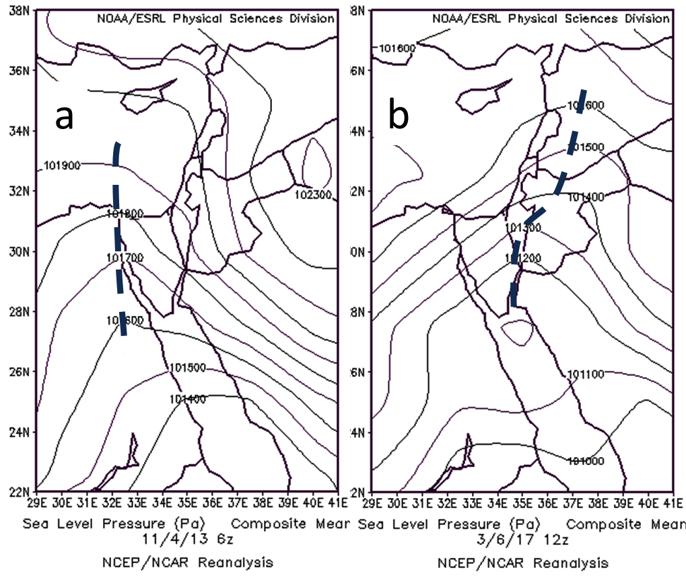

Fig. 1: SLP (Pa) exemplifying an RST with an axis to the west (April 11 06UTC, 2013, a) and an RST with an eastern axis (March 6 12UTC, 2017, b). The axes are denoted by thick dashed lines

Dayan et al. (2012) performed a manual (subjective) synoptic classification, based on sea-level pressure (SLP) maps, for a decade (1995-2004), and compared their results with the semi-objective classification of Alpert et al. (2004a). More than 50% disagreement was found between the two classifications, for each of the three subclasses of the RST. This is far beyond the 10% rate mismatch obtained by Frakes and Yarnal (1997) for well-defined pressure systems with steep gradients.

The weakness of the automated classification of Alpert et al. (2004a) might be attributed to three main causes. One is the coarse spatial resolution of the data, 2.5°X2.5°, which imposes difficulty in determining the exact location of the RST axis. Second is the similarity of the RST to other synoptic systems in the region (e.g., High to the north, west or east of Israel, or a weak Cyprus Low, see Saaroni et al. 1998). The third is the arbitrariness of the area on which the semi-objective classification is based on, extending over the 27.5°-37.5°N, 25°-35°E domain. Moreover, each grid point attains a similar weight in the calculations. The area occupied by an RST may cover only 1/4 of it, while another system, such as a cyclone over Turkey, may co-exist. In such a case the choice of the automatic software is not necessarily RST, though this system is closer to Israel and is probably more relevant for the weather there.

There is need for an improved automatic method for classification of RST, which overcomes the weaknesses specified above as much as possible. The present study aims to offer a flexible algorithm to identify an RST and its position with respect to the Levant, independent of the spatial resolution of data source. Section 2 specifies the algorithm developed and stresses the rationale behind its design. Section 3 evaluates the algorithm performance and elaborates on its response to variations in the data source and resolution. Section 4 presents climatological features of the RST, derived from applying the algorithm to data bases. Section 5 discusses the characteristics of the algorithm and explains why it can be regarded 'explicit'.

1. **Data and methods**

The purpose of the developed algorithm is to identify and classify RSTs at a given point in time, based on atmospheric data supplied by any data source, i.e., reanalysis or model output with a wide range of spatial resolutions. To achieve this goal, and to circumvent the weaknesses of the current automatic classification used in this region (specified in Sec. 1 above), the domain envelopes the northern Red-Sea and Israel and the fields used were SLP and sea-level geostrophic vorticity. The following steps are executed in order: input processing, SLP based troughs axis locating algorithm, required RST conditions check and, finally, RST classification.

* 1. *Input and pre-processing*

To permit input data from different sources with various resolutions, data is first interpolated to a common basis, i.e., grid of 0.5°X0.5° resolution. Such an interpolation of the SLP data was found optimal for identifying and locating the trough axis, see Sec. 2.2 below. The same interpolation procedure is applied on the geostrophic vorticity field, which is calculated first from the raw data, and then interpolated. The reason behind being keeping the original unaltered data for calculations and only interpolating the calculated result for the RSTs 0.5° grid.

* 1. *Locating the trough axis*

The algorithm seeks for an initial local SLP minima, which can be regarded as the core of an RST, extending northward. The searched domain is: 27.5°N - 30.5°N, 30°E – 42.5°E. A grid point is considered as having a local minimum if it has a lower SLP value than both its neighboring grid points along at least one line along 4 directions: north-south, east-west, southwest-northeast and northwest-southeast, at a range of ~1.5°.

If a local minimum is found, the algorithm looks for a local minimum in its immediate neighborhood (which is not to the south of it and must have a higher SLP value) that is a candidate for being the next point in the trough axis. As long as such minima are found, the algorithm keeps looking further for possible next points in the trough. When none is found, the search stops and the grid points that were recorded along the way are considered a trough axis.

It was found for many troughs that different, yet close, trough axes merged into one eventually, as is exemplified in Fig. 2. These are considered as one axis, and its path is considered as follows: for each latitude, in which at least one merging axis exists, the average between the highest and lowest longitudes of all merging axes is considered the merged axis longitude for this latitude. This way the algorithm clears each map from multiple merging axes and leaves at most only 3 axes most of the time (and very often, only 1). These merged axes are the candidates when selecting the RST axis for a given day.

Due to the discrete process of its derivation (Figs. 3a, b), the trough axis looks as a kinked chain of straight segments. Hence, it is displayed after being smoothed.

**כאן ייכנסו דוגמא או יותר של צירים מתמזגים, והדגשת הציר הנבחר. בנוסף, תצוגה של ציר מקורי ומוחלק**

Fig. 2: SLP (contours, in hPa) and geostrophic vorticity fields (colors, in s-1) for ?? (a), ?? (b) and ?? (c), showing RST axes as identified by the algorithm

* 1. *Conditions for RST existence over the Levant*

Considering that the RST is a cyclonic system which region is south of the Levant, a few conditions were specified to be met.

The first of which is the 'SLP gradient' condition, i.e., that the SLP decreases from north to south across the Levant region. The algorithm calculates the average SLP within two areas: 31°N - 35°N, 33°E – 37°E and 27°N - 31°N, 33°E – 37°E (see Fig. 3). If the first value is higher than the second, the SLP gradient condition is met.

The second condition is the 'vorticity condition'. If the average geostrophic vorticity over the region of interest, 29°N – 33°N, 32.5°E – 37.5°E (see Fig. 3) is positive, the vorticity condition is met.

The third condition is that no Sharav Low or an Eastern Low exists in the area. Although some shallow lows can be closed inside an RST and are identified successfully by the algorithm, when the abovementioned low classes are prominent, they dominate the region and “confuse” the algorithm. To prevent that, we look for well-defined Sharav Lows at the 25°-32.5°N, 25°-35°E region and for Eastern Lows at the 30°-35°N, 35°-42.5°E region. A low center (SLP minimum) found in these regions is considered as dominating the region if it has a mean depth of at least 160hPa (low strength) at a radius of 300Km and at least 75hPa to each direction (low shape).

The last condition is obviously finding at least one RST candidate RST trough axis.

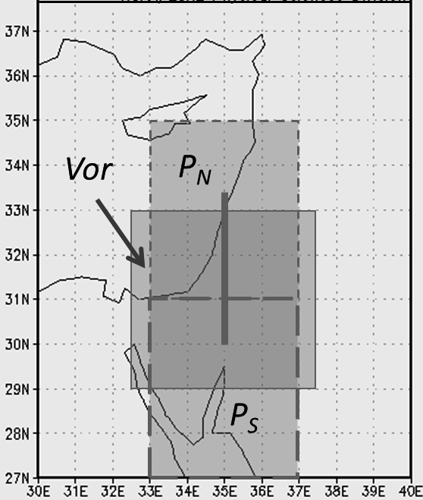

Fig. 3: The reference regions used for analyzing the RST. The areas denoted *PN* and *PS* are the northern and southern regions, respectively, over which the average SLP is calculated to verify pressure drop from north to south and the area denoted *Vor* is the one over which the vorticity is averaged. The thick line along the 35°E latitude is used for determining where the RST axis is located relative to Israel.

* 1. *Final RST classification*

If not all RST conditions are met, the final classification for the input map is 'No RST'. Otherwise, all merged troughs found earlier are classified and one is selected as the final RST classification for the input map, as described below.

Each merged trough is classified as one of the following classes: No RST, RST with an Eastern axis, RST with a central axis or RST with a Western axis. according to its relative location to the region 30°N – 33.5°N, 32.5°E – 37.5°E (see rectangle denoted "Vor" in Fig. 3). If the trough axis does not cross this region, the trough is classified as 'No RST'. If a trough axis is found only in the Eastern (Western) half of the region, it is classified as a troughwith an Eastern (Western) axis. A trough that crosses the region through the line separating between its western and eastern halves is classified as an RST with a central axis.

If more than one merged axes exist for a given day, all merged axes receive a Geostrpohic Voritcity score (GV score) and the one with the highest GV score is selected as the RST axis for that day. A GV score is the total of GV values in each grid point along the axis. This selection method was found to effectively balance axis length and depth, as both are important factors for selecting the right RST axis.The classification of the selected RST axis is the final classification for the input map.

* 1. *Data used*

To test and tweak the algorithm, data was taken from the ERA-Interim reanalysis (Uppala et al., 2005; European Centre for Medium-Range Weather Forecasts, 2009; Dee et al., 2011) with 0.75°X0.75° and 2.5°X2.5° spatial resolutions, and from the NCEP/NCAR reanalysis archive at a 2.5°X2.5° spatial resolution (Kalnay et al., 1996; Kistler et al., 2001). The study period corresponds to the availability of the ERA-Interim data, i.e., 1979-2016. The data was taken for this region: 20°N – 50°N, 20°E – 50°E.

1. Evaluation of the algorithm

Following Alpert et al. (2004a), we started our evaluation on the NCEP-NCAR reanalysis data base, used by them.

**כאן צריכה להיכנס פסקה שמראה כמה הסכמות יש בינינו לבין הזהוי מתוך 100 מקרים שנבחרו אקראית**

The identification of the RST and its axis is expected to vary according to the data base used and to the horizontal in which it is given. Table 1 compare the identification and classification done on three data bases: The NCEP reanalysis with 2.5°×2.5° resolution and the ERA Interim of two different resolutions: 2.5°×2.5° and 0.75°×0.75°. This enable the comparison between the two data centers on the basis of similar resolution and evaluating the effect that the resolution has on the data from the same sources.

|  |  |  |  |  |  |
| --- | --- | --- | --- | --- | --- |
| 1979-2016 |  |  | **ERA** | **0.75°×0.75°** |  |
|  |  | **No RST** | **RST-East** | **RST-Central** | **RST-West** |
|  | **No RST** | **10024** | 141 | 149 | 69 |
| **NCEP** | **RST-East** | 1369 | **397** | 543 | 98 |
| **2.5°×2.5°** | **RST-Central** | 390 | 50 | **381** | 91 |
|  | **RST-West** | 107 | 11 | 47 | **13** |
| **Agreement** | **% of perfect match** | **78%** |  | **% of misidentification** | **16%** |
|  |  |  | **ERA** | **2.5°×2.5°** |  |
|  |  | **No RST** | **RST-East** | **RST-Central** | **RST-West** |
|  | **No RST** | **9753** | 279 | 240 | 111 |
| **NCEP** | **RST-East** | 800 | **679** | 798 | 130 |
| **2.5°×2.5°** | **RST-Central** | 196 | 71 | **495** | 150 |
|  | **RST-West** | 73 | 18 | 57 | **30** |
| **Agreement** | **% of perfect match** | **79%** |  | **% of misidentification** | **12%** |
|  | **No RST** | **10617** | 586 | 500 | 187 |
| **ERA** | **RST-East** | 74 | **288** | 205 | 32 |
| **0.75°×0.75°** | **RST-Central** | 84 | 130 | **796** | 110 |
|  | **RST-West** | 47 | 43 | 89 | **92** |
| **Agreement** | **% of perfect match** | **85%** |  | **% of misidentification** | **11%** |

Table 1: Comparison of RST identification and classification among: NCEP reanalysis with 2.5°×2.5° resolution, ERA Interim with 2.5°×2.5° resolution and Era Interim with 0.75°×0.75° resolution. Each item is one day, represented by the 12UTC map. The period is 1979-2017, total of 13,880 days.

The results of the comparison are presented in table 1. Each block shows the results for one pair of data sets. The bold numbers along diagonals in each block are the number of days, which were identified and classified equally for both data sets for the pertinent type of RST or as 'No RST' days. The percentage of perfect match is the percentage of days, belonging to the four types, being equally classified. The percentage of misidentification is based on the number of days which was identified for one data set as 'RST day' and by the other as 'No RST day'.

The lowest match was found between the NCEP (2.5°×2.5° resolution) and the fine resolution (0.75°×0.75°) data set of ERA Interim, 78%. The percentage of mismatch between them was found the largest, 16%. The highest match was found between the two data sets of the ERA Interim, 85%, together with the lowest mismatch, 11%. The higher agreement between the latter stems, presumably. From the similar processing methods applied for them both.

The degree of mismatch between the classifications of two data sets may reflect inherent inaccuracy of the algorithm, but also differences in the SLP and the vorticity fields due to the differences data processing centers and the different spatial resolution applied on the raw data. The differences imposed on the SLP field doe to the above differences in the processing is exemplified by a case in which a day was classified differently for each of the data sets (Fig. 4). It is easy to visualize several differences among

**דוגמה עסיסית של מפה שזוהתה שונה על פי 3 מקורות הנתונים**

Fig. 4: SLP (contours, in hPa) and geostrophic vorticity fields (colors, in s-1) for ?? ?? 12UTC, which was classified as '' for REA Interim (fine resolution), a, as '' for REA Interim (fine resolution), b and as '' for NCEP reanalysis, c. The

Another aspect of this comparison is biases, which are expressed by asymmetry between the numbers of mismatches as reflected by the off-diagonal numbers. The most prominent asymmetry is found between the NCEP and the ERA Interim fine resolution data. The number of days classified as 'No RST' in the ERA Interim data set and 'RST East' in the NCEP data set is 10 times larger as this of the days classified as 'No RST' in the NCEP data set but 'RST East' in the ERA Interim data set. Moreover the number of the former is 1369' 10% of the total number of days.

**אני נעצר כאן. נראה לי שזה קשור לרגישות לקוי האורך 37.5 ו 32.5. למעזה, המזרחי שביניהם הוא מקור הבעייה העיקרי, שהוא הקו שעליו יש נתונים ברזולוציה הנפוצה של 2.5 מעלות, ושלכן בסביבתו יימצא לעיתים קרובות הציר המזרחי. יתכן שזה גם נהיה קריטי מדי עקב היות קווים אלה הגבולות של מיצוע הוורטיסיטי. בקיצור: בואו נעצור את הדיון הזה לאחר ביצוע הטבלה כשמתחילים את הציר מהנקודה היותר דרומית, ואם המצב לא ישתפר, להרחיב ל 32-38 מעלות מזרח את תחום הבדיקה.**

1. Climatological aspects of the RST

The distribution of RST days along the year is presented in Fig. 5. The maximum is in November and the minimum is in July, in agreement with Alpert et al. (2004b).

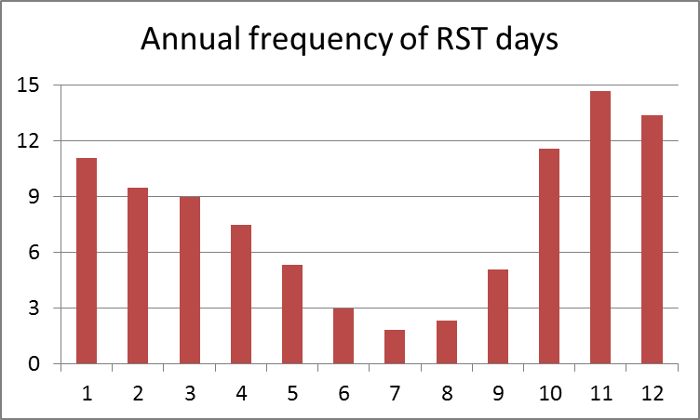

Fig. 5: Yearly distribution of RST days according to the NCEP reanalysis data

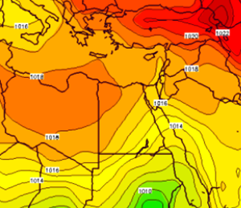

Fig. *: Long-term mean slp (hPa) for November over the Mediterranean Basin; from the NCEP/NCAR CDAS-1 archive. The existence of the RST in this map reflects its dominance in this month over the Levant

1. Summary and discussion

The identification methodology proposed here is "object oriented**???**" or may be called 'explicit', since it does not attempt to identify and classify synoptically the entire set of time points. Rather, it search only for days in which RST dominate the Levant and classify them.

**References**

Dee DP, Uppala SM, Simmons AJ, Berrisford P, Poli P, Kobayashi S, Andrae U, Balmaseda MA, Balsamo G, Bauer P, Bechtold P, Beljaars ACM, Van de Berg L, Bidlot J, Bormann N, Delsol C, Dragani R, Fuentes M, Geer AJ, Haimberger L, Healy SB, Hersbach H, Hףlm EV, Isaksen L, Kוllberg P, Kohler M, Matricardi M, McNally AP, Monge-Sanz BM, Morcrette J-J, Park B-K, Peubey C, De Rosnay P, Tavolato C, Thיpaut J-N, Vitart F. 2011. The ERA-Interim reanalysis: configuration and performance of the data assimilation system. *Q. J. R. Meteorol. Soc.* **137**(656): 553–597, doi: 10.1002/qj.828.

European Centre for Medium-Range Weather Forecasts. 2009. ERA-Interim Project. Research Data Archive at the National Center for Atmospheric Research, Computational and Information Systems Laboratory, Boulder, CO. <http://rda.ucar.edu/datasets/ds627.0>. (accessed 29 December 2014).

Uppala SM, Kוllberg P, Simmons AJ, Andrae U, Bechtold P, Fiorino M, Gibson JK, Haseler J, Hernandez A, Kelly GA, LI X, Onogi K, Saarinen S, Sokka N, Allan RP, Andersson E, Arpe K, Balmaseda MA, Beljaars ACM, van de Berg L, Bidlot J, Bormann N, Caires S, Chevallier F, Dethof A, Dragosavac M, Fisher M, Fuentes M, Hagemann S, Hףlm EV, Hoskins BJ, Isaksen L, Janssen PAEM, Jenne R, McNally AP, Mahfouf J-F, Morcrette J-J, Rayner NA, Saunders

RW, Simon P, Sterl A, Trenberth KE, Untch A, Vasiljevic D, Viterbo P, Woollen J. 2005. The ERA-40 re-analysis. Q. J. R. Meteorol. Soc. 131(612): 2961–3012, doi: 10.1256/qj.04.176.